2. PAGING:
- Paging involves breaking physical memory into fixed-sized blocks called frames and breaking logical memory into blocks of the same size called pages.
- Paging avoids external fragmentation and the need for compaction, whereas segmentation does not.
- When a process is to be executed, its pages are loaded into any available memory frames
PAGING HARDWARE:
- Every address generated by the CPU is divided into two parts: a page number (p) and a page offset (d).
- The page number is used as an index into a page table.
- The page table contains the base address of each page in physical memory.
- This base address is combined with the page offset to define the physical memory address that is sent to the memory unit.
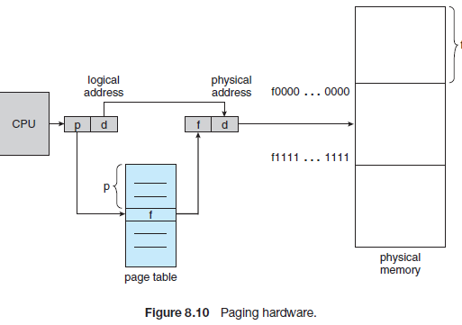
- The page size is defined by the hardware. The size of a page is a power of 2, varying between 512 bytes and 1 GB per page.
- If the size of the logical address space is 2^{m}, and a page size is 2^{n}bytes, then the high-order m− n bits of a logical address designate the page number, and the n low-order bits designate the page offset.
- The logical address is given by
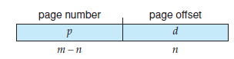
- Here p is an index into the page table and d is the displacement within the page.
- PAGING MODEL:
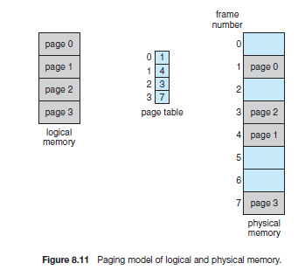
PAGING EXAMPLE:
- 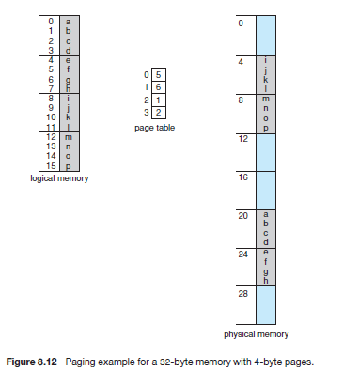
- Consider the memory with the logical address, n= 2 and m = 4. Using a page size of 4 bytes and a physical memory of 32 bytes
- Logical address 0 is page 0, offset 0. Indexing into the page table, we find that page 0 is in frame 5. Thus, logical address 0 maps to physical address 20 [= (5 × 4) + 0].
- Logical address 3 (page 0, offset 3) maps to physical address 23 [= (5 × 4) + 3].
- Logical address 4 is page 1, offset 0; according to the page table, page 1 is mapped to frame 6.
- Thus, logical address 4 maps to physical address 24 [= (6 × 4) + 0].
FREE FRAME LIST:
- Each page of the process needs one frame. Thus, if the process requires n pages, at least n frames must be available in memory.
- If n frames are available, they are allocated to this arriving process.
- The operating system is managing physical memory and knows the allocation details of physical memory—which frames are allocated, which frames are available, how many total frames there are, and so on.
- This information is generally kept in a data structure called a frame table.
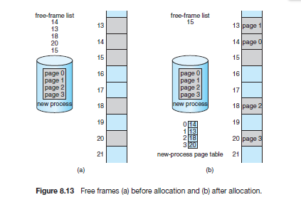
HARDWARE SUPPORT:
- The hardware implementation of the page table can be done in several ways. The page table is implemented as a set of dedicated registers if the size of the page table is too small.
- If the size of the page table is too large then the page table is kept in main memory and a page table base register is used to point to the page table.
- When the page table is kept in main memory then two memory accesses are required to access a byte.
    - One for accessing the page table entry
    - Another one for accessing the byte.
- Thus the overhead of accessing the main memory increases.
- The standard solution to this problem is to use a special, small, fast lookup hardware cache called a translation look-aside buffer (TLB).

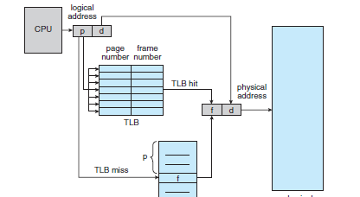

- Each entry in the TLB consists of two parts: a key (or tag) and a value.
- The TLB contains only a few of the page-table entries.
- When a logical address is generated by the CPU, its page number is presented to the TLB. If the page number is found (TLB HIT), its frame number is immediately available and is used to access memory.
- If the page number is not in the TLB (TLB miss), a memory reference to the page table must be made. When the frame number is obtained, we can use it to access memory.
- The percentage of times that the page number of interest is found in the TLB is called the hit ratio.
- The access time of a byte is said to be effective when the TLB hit ratio is high.
- Thus the effective access time is given by
Effective access time = TLB hit ratio* Memory access time +TLB miss ratio* (2*memory access time)

PROTECTION:
- Memory protection in a paged environment is accomplished by protection bits associated with each frame.
- One bit can define a page to be read–write or read-only. When the physical address is being computed, the protection bits can be checked to verify that no writes are being made to a read-only page
- One additional bit is generally attached to each entry in the page table: a valid–invalid bit. When this bit is set to valid, the associated page is in the process’s logical address space and is thus a legal.
- When the bit is set to invalid, the page is not in the process’s logical address space.
- Page-table length register (PTLR),is used to indicate the size of the page table. This value is checked against every logical address to verify that the address is in the valid range for the process
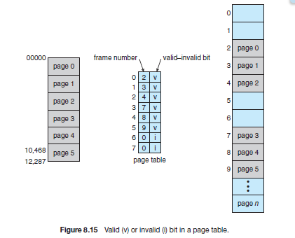
SHARED PAGES:
- An advantage of paging is the possibility of sharing common code.
- If the code is reentrant code (or pure code), however, it can be shared.
- Reentrant code is non-self-modifying code: it never changes during execution. Thus, two or more processes can execute the same code at the same time
- EXAMPLE: Consider three processes that share a page editor which is of three pages. Each process has its own data page.
- Only one copy of the editor need be kept in physical memory. Each user’s page table maps onto the same physical copy of the editor, but data pages are mapped onto different frames.
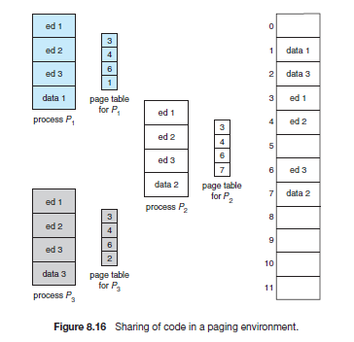

STRUCTURE OF PAGE TABLE:
- The structure of page table includes
    - Hierarchical paging
    - Hashed page table
    - Inverted page table.

- HIERARCHIAL PAGING:
- In Computer a system that has a 32 bit logical address space the page table becomes too large. Each process may need upto 4MB of Physical address space for the page table alone.
- One simple solution to this problem is to divide the page table into smaller pieces. One way is to use a two-level paging algorithm, in which the page table itself is also paged.
- Consider the system with a 32-bit logical address space and a page size of (2 ¹²)4 KB.
- A logical address is divided into a page number consisting of 20 bits and a page offset consisting of 12 bits.
- The page number is further divided into a 10-bit page number and a 10-bit page offset.
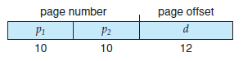
- Here p1 is an index into the outer page table and p2 is the displacement within the page of the inner page table.
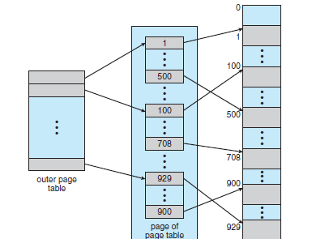

- Address translation works from the outer page table inward, this scheme is also known as a forward mapped page table.
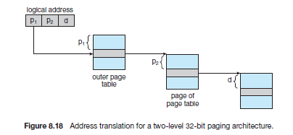
- HASHED PAGE TABLES:
- A common approach for handling address spaces larger than 32 bits is to use a hashed page table, with the hash value being the virtual page number.
- Each entry in the hash table contains a linked list of elements that hash to the same location

- Each element consists of three fields:
    - virtual page number,
    - value of the mapped page frame
    - pointer to the next element in the linked list
- The virtual page number in the virtual address is hashed into the hash table. The virtual page number is compared with field 1 in the first element in the linked list.
- If there is a match, the corresponding page frame (field 2) is used to form the desired physical address.
- If there is no match, subsequent entries in the linked list are searched for a matching virtual page number.
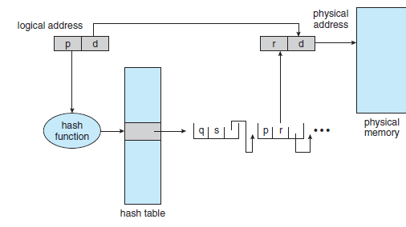

- A variation to hashed page table is clustered page tables, which are similar to hashed page tables except that each entry in the hash table refers to several pages (such as 16) rather than a single page.

- INVERTED PAGE TABLES:
- Each process has an associated page table. The page table has one entry for each page that the process is using.
- The table is sorted by virtual address, the operating system calculate where in the table the associated physical address entry is located and to use that value directly.
- One of the drawbacks of this method is that each page table may consist of millions of entries.
- To solve this problem, we can use an inverted page table.
- An inverted page table has one entry for each frame of memory. Each entry consists of the virtual address of the page stored in that real memory location; with information about the process that owns the page.
- Thus, only one page table is in the system, and it has only one entry for each page of physical memory.
- Each Logical address in the system consists of a triple :< process-id, page-number, offset>.
- Each inverted page-table entry is a pair <process-id, page-number>
- When a memory reference occurs, part of the virtual address, consisting of <process-id,page number>,is presented to the memory subsystem. The inverted page table is then searched for a match. If a match is found—say, at entry i—then the physical address <i, offset> is generated..
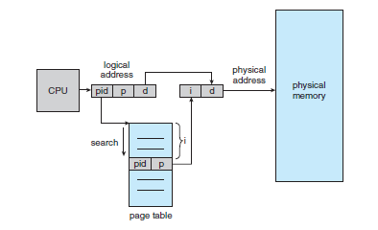
INTEL 32 AND 64-BIT ARCHITECTURES [SEGMENTATION WITH PAGING]
- Memory management in IA-32 systems is divided into two components segmentation and paging.
- The CPU generates logical addresses, which are given to the segmentation unit.
- The segmentation unit produces a linear address for each logical address.
- The linear address is then given to the paging unit, which in turn generates the physical address in main memory.
- Thus, the segmentation and paging units form the equivalent of the memory-management unit
IA-32 Segmentation:
- The IA-32 architecture allows a segment to be as large as 4 GB, and the maximum number of segments per process is 16 K.
- The logical address space of a process is divided into two partitions. Information about the process that are private to the process is kept in the local descriptor table (LDT);
- The information that is shared among other processes is kept in the global descriptor table (GDT).
- Each entry in the LDT and GDT consists of an 8-byte segment descriptor with detailed information about a particular segment, including the base location and limit of that segment.
- The logical address is a pair (selector, offset), where the selector is a 16-bit number:
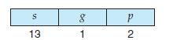
- s designates the segment number, g indicates whether the segment is in the GDT or LDT, and p deals
with protection.
- The offset is a 32-bit number specifying the location of the byte.
- The segment registers points to the appropriate entry in the LDT or GDT.
- The base and limit information about the segment is used to generate a linear address.
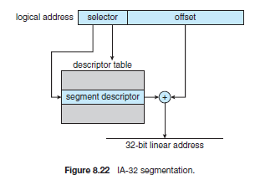
IA -32 PAGING:
- The IA-32 architecture allows a page size of either 4 KB or 4 MB.
- For 4-KB pages, IA-32 uses a two-level paging scheme in which the division of the 32-bit linear address is as follows.
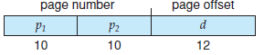
- The 10 high-order bits reference an entry in the outermost page table, which IA-32 terms the page directory.
- The page directory entry points to an inner page table that is indexed by the contents of the innermost 10 bits in the linear address.
- Finally, the low-order 12 bits refer to the offset in the 4-KB page pointed to in the page table.
- Intel adopted a page address extension (PAE), which allows 32-bit processors to access a physical address space larger than 4 GB
- PAE also increased the page-directory and page-table entries from 32 to 64 bits in size, which allowed the base address of page tables and page frames to extend from 20 to 24 bits
VIRTUAL MEMORY:
- Virtual memory is a memory management technique that allows the execution of processes that are not completely in memory.
- In some cases during the execution of the program the entire program may not be needed, such as error conditions, menu selection options etc.
- The virtual address space of a process refers to the logical view of how a process is stored in memory.
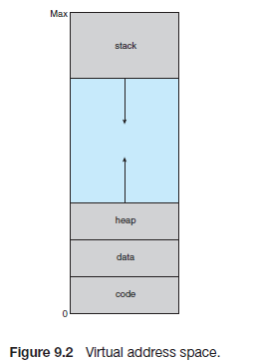

- The heap will grow upward in memory as it is used for dynamic memory allocation.
- The stack will grow downward in memory through successive function calls .
- The large blank space (or hole) between the heap and the stack is part of the virtual address space but will require actual physical pages only if the heap or stack grows.
- Virtual address spaces that include holes are known as sparse address spaces.
- Sparse address space can be filled as the stack or heap segments grow or if we wish to dynamically link libraries
- Virtual memory allows files and memory to be shared by two or more processes through page sharing
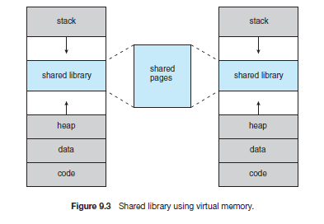
ADVANTAGES:
- One major advantage of this scheme is that programs can be larger than physical memory
- Virtual memory also allows processes to share files easily and to implement shared memory.
- Increase in CPU utilization and throughput.
- Less I/O would be needed to load or swap user programs into memory

